Charts & Tables: User Manual

Charts&Tables.xlsm creates pivot charts and pivot tables based on data located in an external excel file (hereafter, input file).

# Input data requirements

The main requirement to an input file is that every data block in it must contain only one numeric data column. Additionally, there must be only one data block per worksheet; moreover, it has to be in an appropriate location. Figure 1 demonstrates a proper data block.

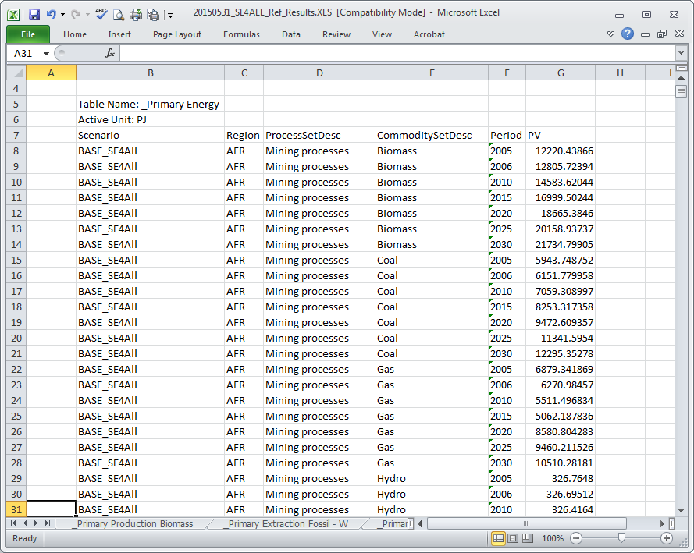

Figure – Example of a data block in an input file that can be used in Charts&Tables.xlsm

# Operation

Figure 2 illustrates an overview sheet in Charts&Tables. Press “Update” to select a new input file or retrieve information from an input file selected previously (i.e. located at the address in cell B2). A dialog menu will appear which will allow either selecting and loading a new input file or reloading a previously selected one. Warning: either of the choices will lead to permanent destruction of data that was contained in Charts&Tables previously.

Dropdown menus located at the right of the “Update” button act as filters.

The box further to the right contains settings with regard to the number of charts in one raw, as well chart width/height (specified in columns/rows).

Left click on any of the chart will display a worksheet with the corresponding pivot table and a copy of the pivot chart.

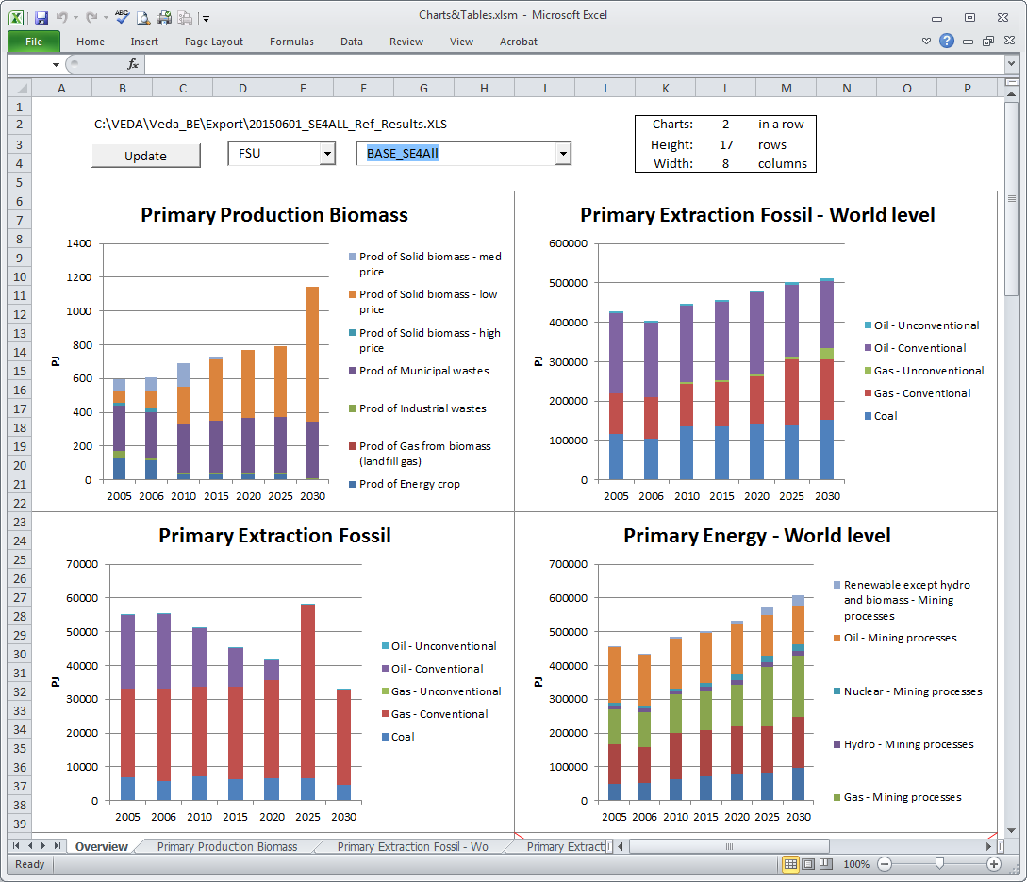

Figure – Example of an Overview sheet in Charts&Tables

# Making an input file with VEDA-BE

In order to create an appropriate input file using VEDA-BE, table definitions have to take into account data requirements in Charts&Tables.

In order to execute a batch export in VEDA-BE:

* Press CTRL+B
* Select relevant table definitions
* Press “View Table(s)” button

Figure 3 illustrates VEDA-BE settings that allow the above procedure to work properly. Press CTRL+O and select “Export Options” to check the settings. The necessary setting are highlighted in red; the export path (can be any) is in blue.

# 

Figure – VEDA-BE settings